West Hull Ladies
RRC

November Newsletter

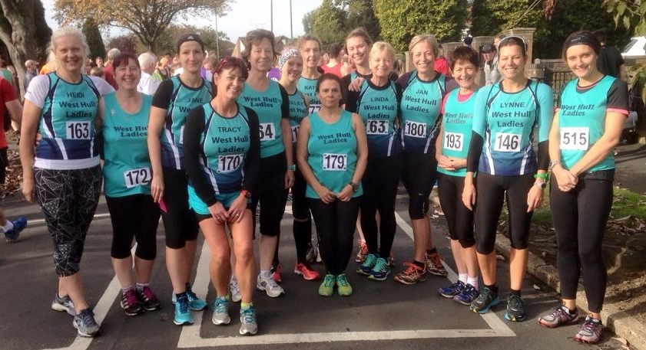

Haltemprice 10K Racing Ladies

West Hull Ladies
WEST HULL LADIES RRC COMMITTEE MEETING

Committee Meeting Minutes
2nd November 2015

Present - Jill, Zoe, Amanda, Anna, Liz, Sandra, Maria, Linda, Jan

- Apologies were received from Annette and Rachael
- Minutes of the previous meeting were agreed.
- Matter arising - none
- 0-5k. Amanda updated the Committee on the different roles members had offered to take on in order for the course to run successfully. Amanda had completed the ‘advert’ for the course which she would now upload onto the website. Annette would send out the welcome emails and also send out an email to ladies booked on the course 4 weeks prior to it starting. Liz would be responsible for media, Linda to maintain the register and Jill and Anna would be responsible for providing training feedback to the ladies on the course as well as to answer any queries they emailed in with.
- Maria updated members that HAN would no longer exist as from December and as such funding for new Leaders would have to come from another source. Action - Maria to contact Heidi Bradley, England Athletics and Gareth Roberts re any funding they could provide.
Maria was thanked for the time effort and enthusiasm she had shown by attending these meetings on behalf of the Club
- Maria informed the committee that we had no hoodies left. A discussion took place on how to source more. Action Sandra to contact pb teamwear for a price. It was also agreed to sell the old style long sleeved vests for £10.
- Advent Calendar run is to be held on Monday 21st December. Maria offered to bring food and drink. The Committee accepted this kind offer. Linda to organise the hire of a room at the YPI and Jill would sort out the projector and photos.

Meet a Member: Lynne Parkin

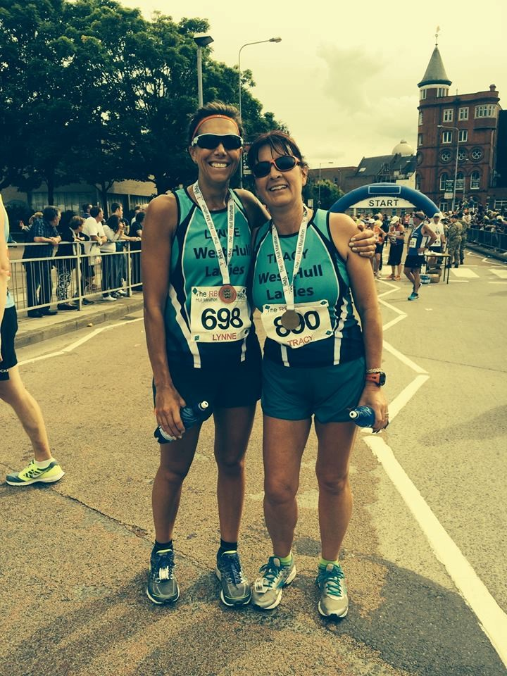
Age 43

Member of WHL since – October 2013

What do you do when you’re not running? – When I’m not running, I work full-time as a HR Manager currently within a School. I live with my partner Matt who is a Surveyor and we’ve been together for nearly 19 years and our cat, Fred. Other than running I like to keep in shape and do something every day except Saturday, that’s usually my rest but unfortunately we are currently in the process of a full house renovation so I still have to exercise whether I like it or not on a Saturday.

How long have you been running? Properly for about 4 years although more competitively since joining WHL

Why did you start running? I like the freedom of the outdoors in all weathers especially after being cooped up all day in an office and I also like running with like-minded people and the chit chat that goes with it.

Favourite distance – I really enjoy the challenge of long distance so half marathon over a 10k any day.

Favourite bit of running kit – ooh erm probably my Garmin

Any injuries? – not at the minute, I seem to be recovering nicely from my hip and foot problems that got worse during marathon training.

Running goals? – I’m not sure I dare say it but I think I’d like to do another marathon, will see how I fair in East Hull 20 in March first though.

Proudest moment running related or otherwise – Doing my first marathon this year and running with so many wonderful people

Best piece of advice you’ve received – Ann Holmes once said that it’s better to start off running and be cold in the first mile then find 5 miles down the line you’ve overdressed and still have another 5 or 15 miles to run! I like to ask Zoe what she is wearing as she always seems to dress right for the weather!

Running alone or with friends? – I can do both but always prefer company!

What keeps you motivated? – A few things really, mostly all the members of the club and other runners and squeezing into a good pair of skinny jeans.

Kielder 10K : Jan

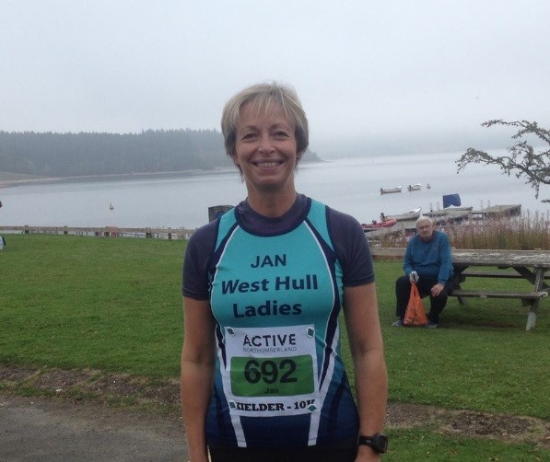Before the start – felt so proud wearing my WHL vest.

This is a mega weekend of running! The 10K takes place on the Saturday, along with a Run-Bike-Run race too, and then the half marathon and marathon take place on the Sunday. Kielder Lake and the gorgeous surrounding countryside is a wonderful back drop for these races. But don’t be seduced in thinking because the courses are around the edge of a lake that they are flat! Far from it! They are tough courses.

This was my first ever off road 10K race and I was conscious that I was coming off the back of the Hull Marathon and also still nursing Plantar Fasciitis. But I’d been doing some faster and shorter training and was hoping to put in a reasonable effort. Looking at the finish times for last year’s F50 category, I thought I’d be able to get on the first page of those results for 2015!

The event is well organised with shuttle buses taking participants (approximately 500) and spectators from the car park (some 5 miles away) to the event start at Leaplish. Conditions were great for running – cool but dry with a hint that the sun might break through the characteristic Northumberland mist. The course is all off-road, bar a small tarmac stretch, and was dry and soft underfoot – good for the Plantar Fasciitis! But it is a demanding course and includes plenty of ups and downs. I was aiming for 8.50 minute miles but the first mile had a pretty sharp hill and consequently I was off pace at 9.13. But where there’s ups there’s downs and
I made up for that slower first mile, although the downs can be pretty hard on the quads too. As well as doing some shorter and faster training, I have also been trying to work on my head, working on the brain messages and self-talk. So I was reciting mantras like ‘this is not really a hill, it’s just an optical illusion’ and ‘you can really do this’ or ‘don’t you dare think about slowing down let alone stopping’. Knowing that I had some support along the route was also a great motivator. So before I knew it, I was crossing the finish line to fabulous support from all the spectators. I was pleased with 54.28 and 6th F50 lady (out of 47). Finishers were then guided through to a tent to collect medals, T shirts and goody bags (which were fab!) and then directly through to the bag-drop tent – really good organisation.

So that was my effort over and done with – Andy’s turn for the marathon on the following day which he completed in a fantastic 3.50. Apart from the Hardmoor marathons, he said Kielder was by far the toughest he’d done. So if any of you hardy ladies are thinking of doing Kielder – be warned!

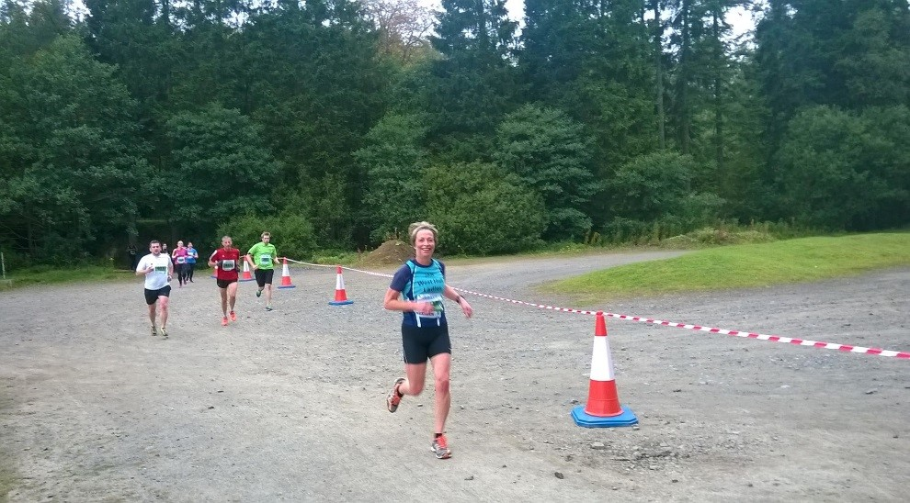

Haltemprice 10K : Sharron

Well, this one was Nige’s fault…… but in the end I did enjoy it.
Since starting my running up again around April time - and that had started with the 0-5k - I hadn’t run more than 3 miles, the park runs. Nige had the idea for us both to run this and I did do the usual ‘shall I, shan’t I’ but in the end he said that

I could always pull out if I didn’t feel as though I was ready. So, I started running to and from club for the Monday night sessions to start slowly building up my mileage and a couple of times went out with Nige and managed 6 miles plus.
Finally the day approached. I was very nervous, I had no idea why!!! I think it was the whole “blimey, I haven’t done THIS for a while” thought running round my head. I was also frightened I’d go the wrong way as I knew I wouldn’t be in amongst the pack of runners near the front but toward the back stretched out. Even with assurances from Nige that “even YOU can’t possibly get lost” er, thanks Nige(!) I was still really nervous.

We met up with other WHL in Haltemprice café and then walked over to the start line. A lot of WHL had turned out to support everyone, my running buddy Ruth was there too. All this support was very much appreciated.

We had the usual photo session and we were off. My thinking was to run to around 3 miles and then see how I felt, whether I felt I needed to walk or not. I felt confident (even with the long incline at the beginning) I could make it to 3 miles. I was then hoping I’d get into my stride, take it a mile at a time and then that would enable me to run the whole race. There were 3 WHL’s who I could see in front of me and I kept my eye on them. One was Diana, Shelley (I think) and Jane. 3 miles came and went, I felt ok. I carried on, though I think I set off quicker than I should have as I certainly felt the 2nd and 3rd miles in my legs!

I had Diana in view ahead of me and concentrated on her at all times!!! (You seemed to be running really well Diana, you looked good). I did have several chats throughout, one with a lovely lady from Beverley Athletics, we kept each other going for a while until she pulled ahead, then Sarah Tock was sent to me by an angel from Heaven, I shall explain: It was around the 4.5/5 mile mark and I must have moaned (or swore, who knows) out loud and I just heard “Are you ok Sharron?” and there was Sarah running up to the side of me. We had a quick chat, telling each other that we were doing ok, she ran ahead of me and for the next few minutes, while we were in range, we kept shouting to each other that we were ok, she then pulled ahead. It was just what I needed, it spurred me on again. I looked up and saw Diana again which added to my determination to finish.

I then just got stuck in with the help of the support. Running towards the end I saw Nige who met me at the bottom of the last hill and ran up it with me – thank you very much Nige, I so needed that!!!! My friends and their daughter, who had kept it a secret from me that they were going to come and support me (cheeky!!) were there cheering and clapping, I saw Kate who shouted support, saw LOADS of WHL near the finish cheering me in, Nige peeled off and Linda took his place. OMG the support – OMG THE FINISH!!!! I have to admit, running that last 200m or so, I got so VERY emotional. I collected my cup, saw Nige and cried. I saw Amanda and Linda and cried. I saw Ruth and cried……do you sense a pattern here???!!!!

I was absolutely thrilled when I learnt that my time was 65:44, I was so happy with that. Also, I was very proud of myself for running the whole of the 10k, not feeling desperate to walk once.

Well done to each and every one of the WHL who ran this 10k and to those who ran Brigg also.

Thanks to everyone who supported.
Xxxxxx

Brigg Poppy Race: Jill

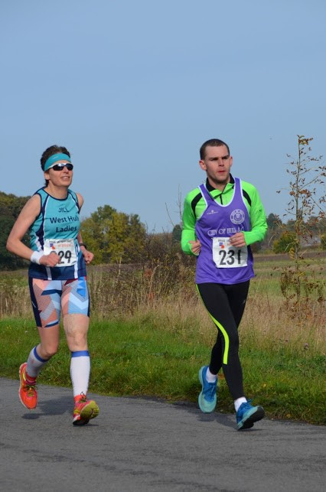

I had not done the Brigg 10k before and had heard that is was a nice event and quite flat so I opted to have a go at this race rather than going for the Haltemprice 10k, which is somewhat more hilly! (Its not the uphills that bother me to be honest, it is the sustained down hills that I find difficult). Zoe, Sandra and Johanna had also opted for this race, and we also had my son (speedy) Mike and his guide runner Adrian with us. A good thing about this race is that it is really quite laid back, but also has a really good atmosphere. They also have an army challenge which starts 15 minutes before the 10k, where people have to do the event in boots and a heavy back pack (clearly nutters!). We had to walk to the start all together in a big group to begin with and as we were walking along, we were serenaded by someone playing bag pipes, which although sounds bizarre, was actually really good. Even Mike who due to his autism is often sound sensitive seemed to be enjoying the bagpipes, although he ran away from the

Nottingham building society mascot (a large green man!)…but I don’t really blame him to be honest! On starting the race Mike and Adrian sped off into the distance, as did Zoe. I always start off quite steady and wind up my speed, so by around the first mile and a half I had caught both Zoe and Mike, although in respect of Mike it was because he had stopped at the side of the road to wait for me! So me, Mike, Zoe and Adrian ran together for most of the first half of the race, which passed without incident. The half way point was actually through a small village which was great, but there were quite a few people cheering and clapping. Now I don’t know why, but this always promotes Mike to suddenly speed up, which he did. I’ve had this problem at parkrun where people have been encouraging the runners, which seems to make Mike run twice as fast! Poor Adrian nearly ended himself going after Mike. I contented myself with the thought that Adrian is a fit young man and should have no problem in staying with Mike. Heading back towards Brigg, I caught Adrian and Mike again and all started running together. Mike however, obviously bored with the whole running thing decided to add interest, so he proceeded to run along leaping in the air, jumping over holes in the road, doing high stepping similar to dynamic stretches, then he would talk to himself and wave his arms about, then he would put his arms behind his back and run along with his arms folded behind his back etc etc!

Now you would have thought that this would slow him down, but actually he seemed to be going faster. Apart from the odd time when he tried to hold my hand and then my vest and be pulled along, I kept on having to call him back. At around four miles, I realised that Zoe and Adrian were not with me (Brilliant??!!). I dare not look back as Mike was on a roll, and I was only just being able to keep up with him by shouting to him to wait for me all the time as he wound up his speed! Whilst the spectators were cheering people to go faster, I spent most of my time shouting to Mike to slow down. As we overtook one of the runners she gave me such an odd look as I shouted after Mike, that I had to explain that he was autistic and if he got away, I would never catch up. Of course, it was only a matter of time. On coming back into Brigg, Mike finally made a run for it.

Speeding off down the wrong street, the marshals fortunately were able to call him back, but by the time I got around the corner onto the finishing straight, Mike was sprinting/leaping in the distance like Tigger on speed! Fortunately I did manage to find him after a bit of a panic. I was very pleased with a new 10k PB (49:09)…Thanks Mike (48:47)!

Grusome Twosome : Linda

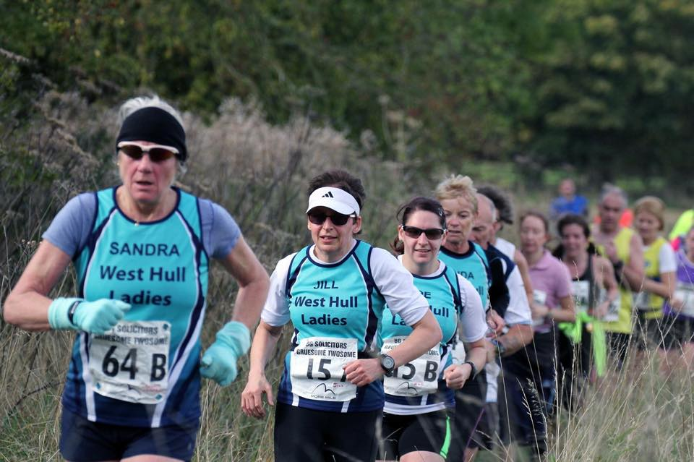

A few months ago Sandra said ‘why don’t we enter the Gruesome together’? What a good idea (I thought)! So we entered. I’ve not done this race before so didn’t know what to expect other than it was all off road!
Before the weekend I had a trip with my work colleague to Santorini (Greece) for a week. Now my colleagues are not sporty at all but I took along my running kit and only managed 5 short runs in the searing heat, the longest being 4 miles, the downhills were good even in the heat but the uphill back to the villa was no joke. I also ate loads and even though we were working and walking dogs all morning each day they weren’t doing it at my pace I was forever being told off for walking too fast! I even swam daily too. Of course the weather was superb so no hardship really.

I came home and it was freezing here (well to me anyway), and I brought home a lovely cold as my room mate had one to start with and was sniffling and coughing all week. So I didn’t run at all the week leading up to this race. I also weighed myself and I had put on 6lbs (shock horror that’s got to go)!
Met up with Sandra at the Humber Bridge and off we went, loved catching up with her after not seeing anyone from WHL for like forever really! The race doesn’t start until 11am which I think is far too late I much prefer an earlier start like around 10am. We had some photo’s taken of all the WHL that were taking part and there were quite a few of us, lovely to see all those vests.

Finally we were off, the sun was shining, it was a tad windy and I hoped I could remember how to run. I was dressed in long tights, warm long sleeve top plus vest the most I’d run in since last winter so I felt a little strange but as the race progressed and the sun went in I was thankful of those extra layers. We hadn’t gone far before we came to a steep hill and it went on for a long way, then across the top before entering some woods, the path was narrow so no overtaking could be done which I was thankful for as it takes me around 3 miles to warm up! The countryside was beautiful when you weren’t watching the feet of the person in front of you or looking out for tree roots. It wasn’t long before I lost sight of Sandra she’d gone off at her own pace, I was struggling a bit I did think my cold had completely gone but the strong winds had taken my breath away and I realised it hadn’t, but through gritted teeth I continued, I was not enjoying myself and usually off road is my best. Still we all have our off days and this was going to be mine.

It was comforting to see that Sally and Debbie up a way in front of me were also walking the hills as was Zoe (although the tough Jill was still running, just what is she on and can I have some please)! There were so many hills and I don’t remember quite the same downhills and the wind, oh boy the wind was gale force by now and so cold. Anyway I plodded on (yes plodded, it felt like I was running in treacle with hob nailed boots on)! Finally catching up to Sandra where she was waiting for me with just over 500 metres to go, even this distance seemed like a long way, finally the finish. Not my best race but at least if I decide to enter next year I’ll know what to expect and also not to go on a holiday before it or catch cold!

Poor Sandra had fell though so we visited the St Johns Ambulance where they cleaned her up and got rid of the grit out of her chin, ouch. Great service from St Johns.

The beanie hat was great to receive makes a change from a T Shirt and a most welcome cup of soup with a roll then we were on our way home. I must have been a bit run down because I was still cold when I got in, hubby was just off for a dog walk and I couldn’t even be bothered to join him and was thankful that I could have a hot shower in peace, put the heating on full and curl up on the sofa to thaw out, I felt so drained. The next morning my legs ached so much.
The Hull Marathon was far easier than this race! See if my name is on the entry list next year!

Derwent Water Ten: Jan

The 56th Derwent Water Ten road race, organised by Keswick AC, was on 1st November and along with a contingent from Beverley AC and a couple of runners from East Hull Harriers, I had somehow found myself on the start line! The route starts in the Centre of Keswick and loops around Derwent Water in a clockwise direction and takes in the wonderful scenery of this part of the Lake District. We were blessed with fantastic weather; sunshine and blue skies and a temperature of about 18 degrees.

The route is described as ‘undulating’ – a word I am always suspicious of! I had been warned that it had two reasonable climbs at miles 5-6 and 7-8. And I can vouch that the course is definitely undulating! It was tougher than I had imagined – harder than Ferriby 10 – and as well as these two tough climbs which each went on for a mile or so, there were some other little ups and downs along the rest of the route. But despite the challenge the course threw at its runners, the surrounding scenery was breath-taking. And even though it was hard work to get to the top of the climbs it was well worth the views.

I was hoping to come in somewhere between 1:25 and 1:27 (my best Ferriby 10 time is 1:26) but in the end I came in in 1:28 which given the nature of the route, I was pleased with. Andy was disappointed with 1:11 (!!). It was really interesting to go to the prize giving too and to see the winners in the various categories including the overall winner (in 51 mins, yes 51 mins – unbelievable!) and the winner from East Hull Harriers in the M75 category. I hope I’m still running when I’m 75!

So girls, I think this would be a great candidate for a West Hull Ladies on Tour event next year! I would be very happy to organise if there was enough interest. Great excuse for a weekend away!

Jan

Guy Fawkes 10: Liz H

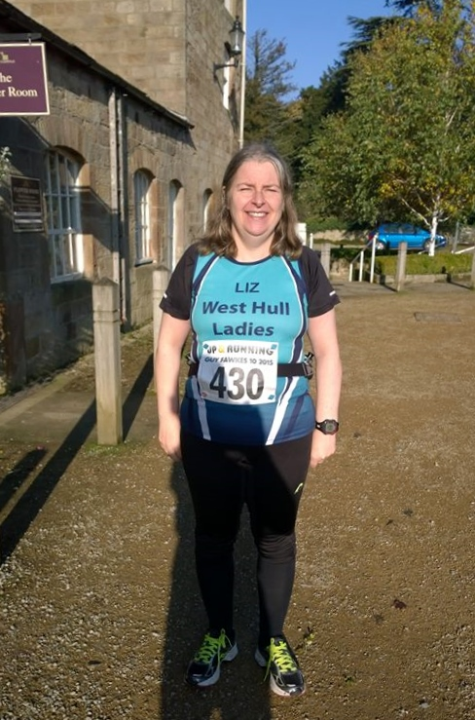
On Sunday 1/11/2015 Chris and I set off to Ripley Castle for the Guy Fawkes 10 mile. It was my idea and I had weighed up a couple of options including the Halloween Half marathon, but in the end I went for the “easier” 10 mile option. (Note to self, check out the route properly before deciding on what is easy).
The day had started out foggy but as we arrived at Ripley the sun came out and it ended up being a spectacularly beautiful day. We asked a few runners who had done the route before and they said it was a very hilly course, I started to get a bit worried when I realized that a lot of these runners were from the West Riding, which of course is really hilly I definitely had a Tellietubbie “Uh Oooh!” moment!
The early course was undulating but generally up hill and I was already struggling, I also had a problem that the pouch on my bottle belt with my mobile phone in frayed and fell off, so I had to carry this in my hand for the majority of the race. I was hoping to break the 2 hour mark, but quickly came to the conclusion that I'd be happy with a finish! I noticed one lady turn back after a mile.

At around the 2 mile stage the hills really started in the form of the Birstwith Brute. At first I was determined to try to run all the way, but I realized that walking up briskly was quicker than actually running and used less energy. This seemed to be the strategy adopted by a lot of the runners. The marshalls were very encouraging and I kept having a joke with them about the lack of hills in Hull! One marshall encouraged us by telling us we were on a downhill stretch which was definitely up hill! I began to think that this area is so hilly that even the downhills are uphill round here!
I was relieved to get to the top of the Brute, which was the longest and most difficult hill, but there are two other lesser hills including one they call “For Fawkes sake”. The good news is that there are long downhill sections as well and once you get the first half over it is easier. I also noticed that my technique for running downhill was more effective than a lot of the runners, (thankyou Amanda!) I was also delighted to see Susan from York Knavesmire who I had run
along with at Snake Lane, she was very encouraging and was much stronger than me at this point. She told me she'd had a very busy weekend having done
a parkrun on Saturday and then been orienteering with her grandchildren, (which seemed to have proved more challenging for her than this race!).
I have to say I was very relieved to get close to the finish and again the undulating nature of this part meant that the very final bit is a short up hill. This time I was determined to run the last bit although my legs were pretty much screaming at me! I saw Chris at the finish and there were a number of competitors and marshals who cheered me home!
I really enjoyed finishing the race! My time was 2 hours 10 mins and 28 secs, and Chris managed an awesome 1 hour 32min 33 secs, but even he had to walk up the hills which made me feel a bit better. The race was brilliantly organised and the we got a lovely orange technical t shirt and a goodie bag with 4, yes 4 full size chocky bars.
If you fancy a proper challenge this is a great one to do and it's a beautiful course! Would I do it again? Maybe!

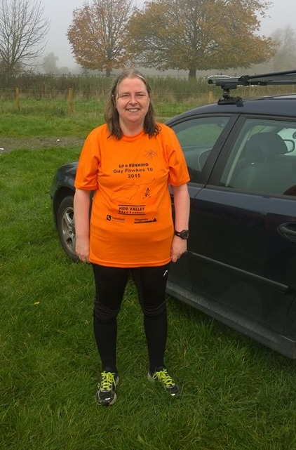
Prizewinners

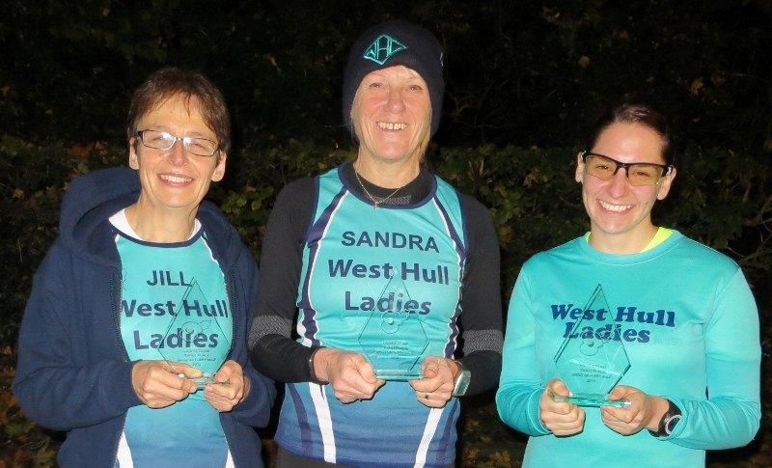
Brigg Poppy Race: Jill, Sandra and Zoe 3rd Team Prize

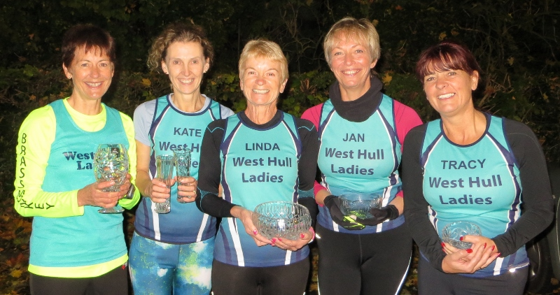
Haltemprice 10K: Amanda 3rd, Kate B 3rd FV50, Linda 1st FV60 Jan 2nd FV50, Tracy 3rd FV45

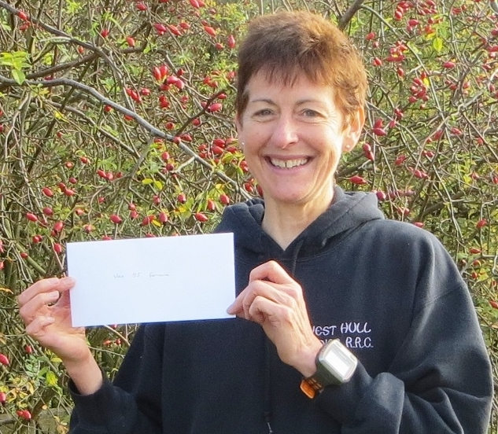
Deepdale Dash: Amanda 1st FV55

Advert: 0- 5 K course

The beginners running course is to take place again in January 2016
We already have 3-4 ladies interested in the course. There will be a limit of 20 places. If you have friends, family or colleagues interested in taking up running in a very supportive environment, please point them to our website.
After reading about it, if still interested they should use the contact link from the page to drop us an email where their questions (and any concerns) can be answered and they can book onto the course.

Please can you advertise http://westhullladies.org.uk
Here is the link to the leaflet: Six Weeks to a 5K - Leaflet.docx
If you are able to pin it up at work/school (for 16 years and over) please do.

Fundraising News: Fatma

Hey ladies! I'm organising a tea party to raise money for Refuge Charity.
All welcome and exclusive to WHL. Please let me know if you can make it.
Cakes made by me.
Fatma

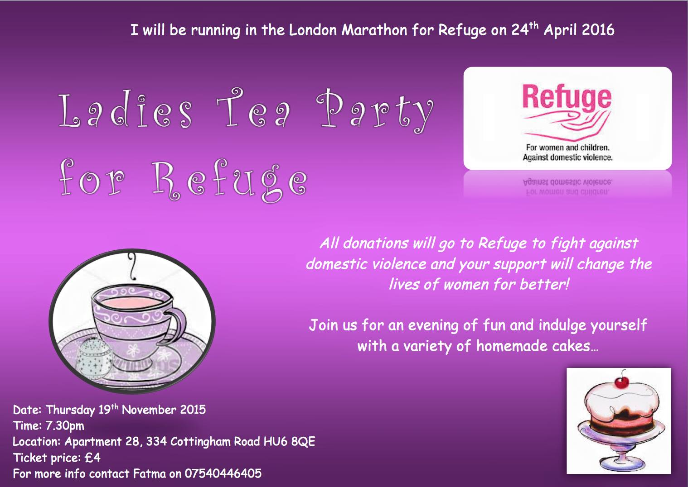

Fundraising News: Sandra

I am running 3 marathons for Crohns and Colitis UK.
So far I have completed Boston (April 2015) and on the 27th September 2015 I shall be running Berlin and in April 2016 London. Having run York in October 2014 I will by the time I have finished run a marathon every 6 months. As many of you know the hard part of the Marathon is the training and I can tell you that is does not get any easier. However when I am running I do think of what I am fundraising for - no matter the hard work it is nothing in comparison with what sufferers of this disease live with everyday.
Why did I pick Crohn's and Colitis?
It was a massive support to me when my daughter was first diagnosed with Crohns just after I ran the London Marathon in 2012. For an adult it is a horrible chronic (lifelong) disease but for a teenager it can be overwhelming and it is certainly life changing. Your health is never something to take for granted.
The charity works to support all those affected by inflammatory bowel diseases to achieve a better quality of life, improve services and ultimately find a cure.
More and more young people are being diagnosed with the disease and I feel that the charity needs all the help it can get not only to try and find a cure but to raise awareness. Most people can look well on the outside but they are far from that.

Any donations would be gratefully accepted - every single £1 would be of a great help.
I do have a justgiving page if anyone would like to make a donation
www.justgiving.com/Sandra-Holdsworth/
Many thanks
Sandra

Fundraising News: Tracy
Just to let you both know that my final total for running the Hull Marathon is £415, this has been sent to my chosen charity … Cancer Research UK. Thank you for your generous donations.
I enjoyed the whole experience and would definitely consider running it again next year.
Once again, thank you.
Tracy

2015 RACE DIARY
http://westhullladies.org.uk/races.htm

Free 5K time trial every Saturday 9am: Hull Parkrun or Peter Pan Parkrun Humber Bridge parkrun

 | Date/Time | Event | Fee | Entry forms | Online entry
November 2015
 | 8th/ 11.00 | Dalby Dash | £11 UKA/£13 | Online entries only | online entries
 | 15th/9.30 | Leeds Abbey Dash 10k | £22UKA/  £24 | Online entries only | Online entry
Please remember to double check dates, times and entry fees with the official website or the entry form. Zx

Keep checking the website for new races and updates:

NOTE: Club Vests must be worn at any races you enter
under the West Hull Ladies running club name.

West Hull Ladies Road Running Club
Kit Order Form

FORENAME ___________________________________

SURNAME ___________________________________

ORDER - tick what you require and circle your size Price
- VEST SIZE 10 12 14 16 £16.00
- LONG SLEEVED SIZE 10 12 £10
- HOODIE SIZE XS S M L £20
- HOODIE with ZIP SIZE XS S M L £20
Note on size, M is approximately size 14
- BEANIE HAT £6.50
- PINLESS WHL NUMBER FASTENERS (set of 4) £3.00

DATE Ordered _______________

AMOUNT PAID _______________

Please transfer payments online with your name and marked as ‘Kit to:
Account: 63762742 Sort Code: 20 43 49

Or cheque payable to ‘West Hull Ladies RRC’, and write your name and ‘Kit’ on the back and give to Club Treasurer Linda Dodsworth, 110 The Stray, South Cave, E Yorkshire. HU15 2AL

Sign on receipt of goods _________________________________
DATE _______________

Please complete this form and email to diazmaria@btinternet.com
Thanks.
Maria Kit Officer

